Practical 4: Ability to Track Source Code & Training Data Using AWS CodeCommit

What is AWS CodeCommit?
AWS CodeCommit is a fully managed Git repository service that stores source code securely in the cloud. It tracks every change made to project files and allows teams to collaborate efficiently.
Note: Large datasets are usually stored in Amazon S3, while CodeCommit stores code and configuration files.

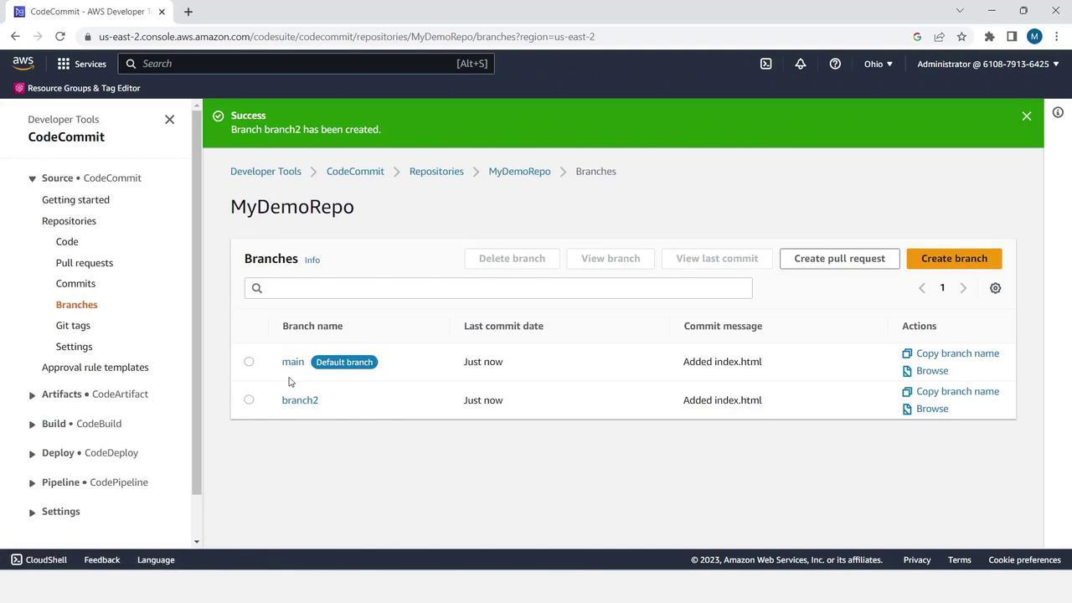
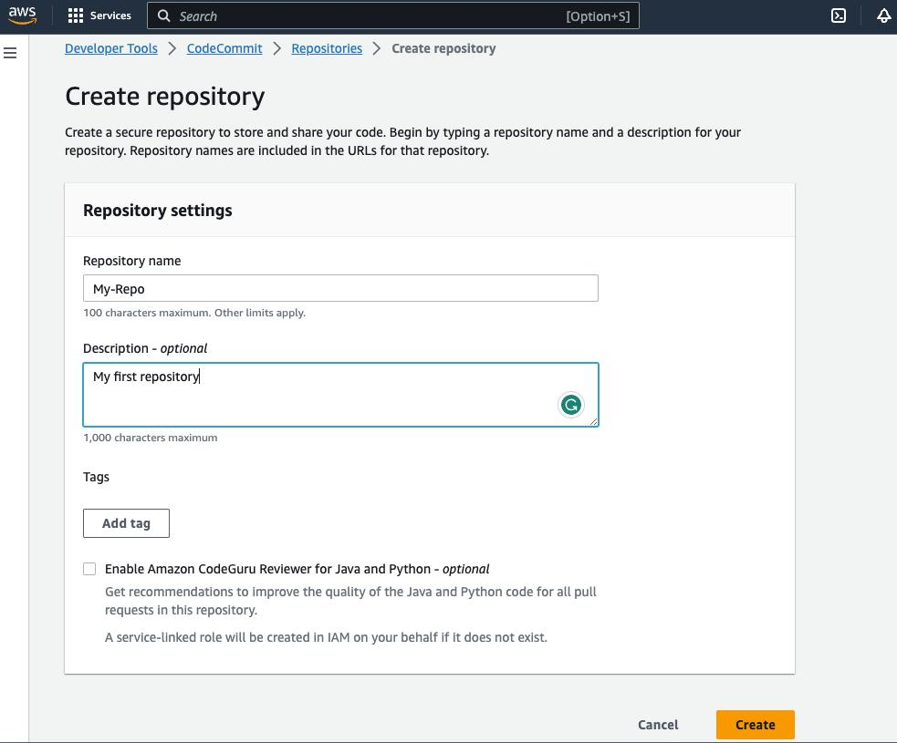
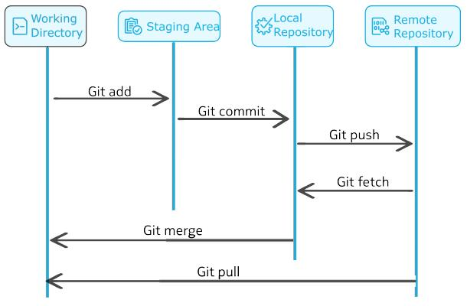

Step 1: Sign in to AWS
- Open the AWS Console.
- Sign in with your AWS account.

Step 2: Open CodeCommit
In the AWS search bar, type:
CodeCommit
Click CodeCommit.

Step 3: Create a Repository
Click Create Repository.
Enter:
Field | Value
Repository Name | Telecom-MLops
Description | Telecom Tower Prediction Project
Click Create Repository.

Step 4: Install Git
Download and install Git.
Open Command Prompt and verify:
git --version
Example output:
git version 2.49.0

Step 5: Configure Git
Open Command Prompt.
git config --global user.name "Your Name"
git config --global user.email "your_email@gmail.com"
Check the configuration:
git config --list

Step 6: Open Your Project Folder
Go to your project folder.
Example:
Desktop
│
└── MLOPS
│
└── prac_1
Open Command Prompt in this folder.

Step 7: Initialize Git Repository
Type:
git init
Output:
Initialized empty Git repository
This creates a hidden .git folder to track all changes.

Step 8: Check File Status
Type:
git status
Output:
Untracked files:

train.py
app.py
tower_telemetry.csv
metrics.json
These files are not yet tracked by Git.

Step 9: Add Files
Type:
git add .
Check again:
git status
Now the files are staged for commit.

Step 10: Commit Files
Type:
git commit -m "Initial MLOps Project"
Output:
[master] Initial MLOps Project
Git has now saved the first version of your project.

Step 11: Connect to AWS CodeCommit
Copy the Clone URL (HTTPS) from your repository.
Example:
https://git-codecommit.ap-south-1.amazonaws.com/v1/repos/Telecom-MLops
In Command Prompt:
git remote add origin https://git-codecommit.ap-south-1.amazonaws.com/v1/repos/Telecom-MLops

Step 12: Push Files
If your branch is main:
git push -u origin main
or, if your branch is master:
git push -u origin master
Wait until the upload completes.
Refresh the CodeCommit page.
You will now see all project files.

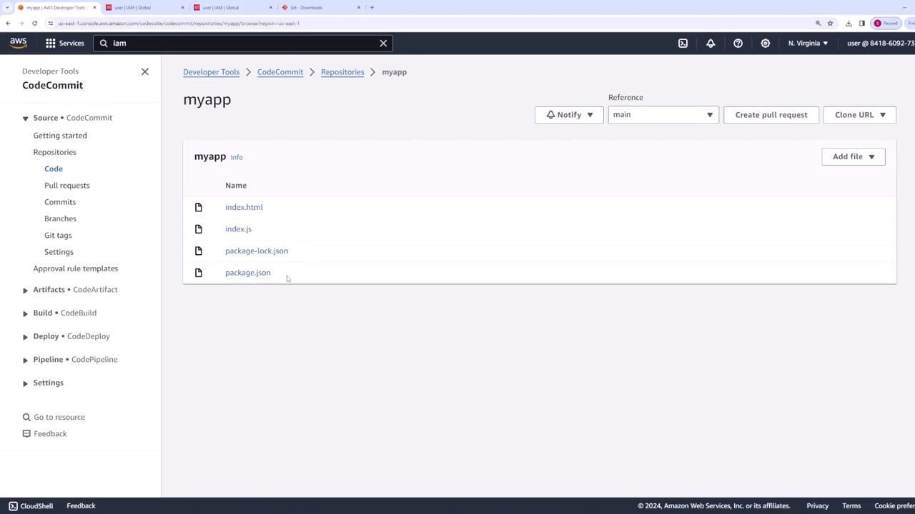
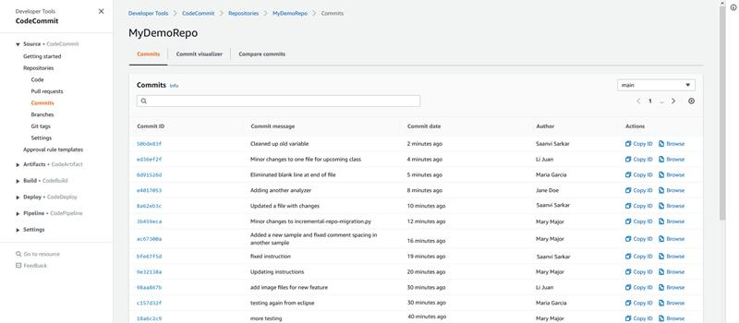
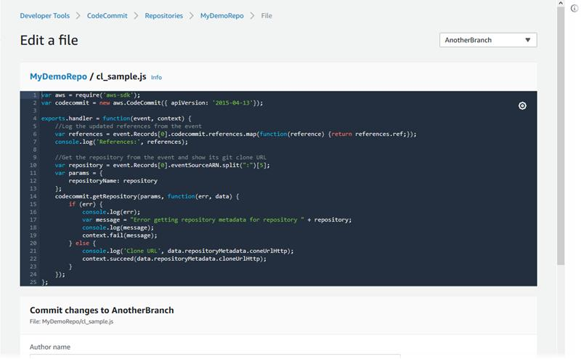
5

Step 13: Modify a File
Open:
train.py
Add:
print("Training Started...")
Save the file.

Step 14: Check Changes
git status
Git will show:
Modified:

train.py

Step 15: Commit Updated File
git add train.py
git commit -m "Updated Training Message"
git push
The new version is uploaded to CodeCommit.

Step 16: View Version History
Open the repository in AWS.
Click Commits.
You will see:
Commit | Description
Initial MLOps Project | First version
Updated Training Message | Second version
Git keeps every version of the project, making it easy to review changes or restore previous versions.

